Task 2: Memory Accesses

1. Venus setup for Scenario 2 showing Program parameters, Cache parameters etc
The program parameters are shown below
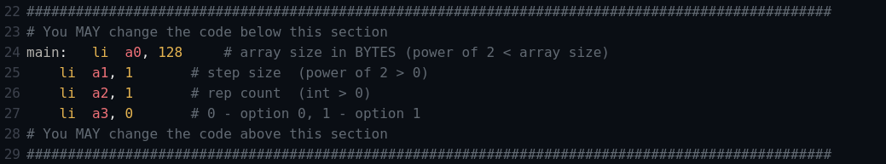
The L1 cache parameters are shown below
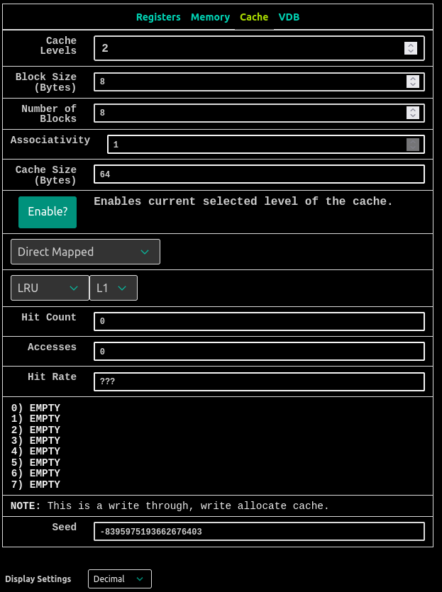

The L2 cache parameters are shown below
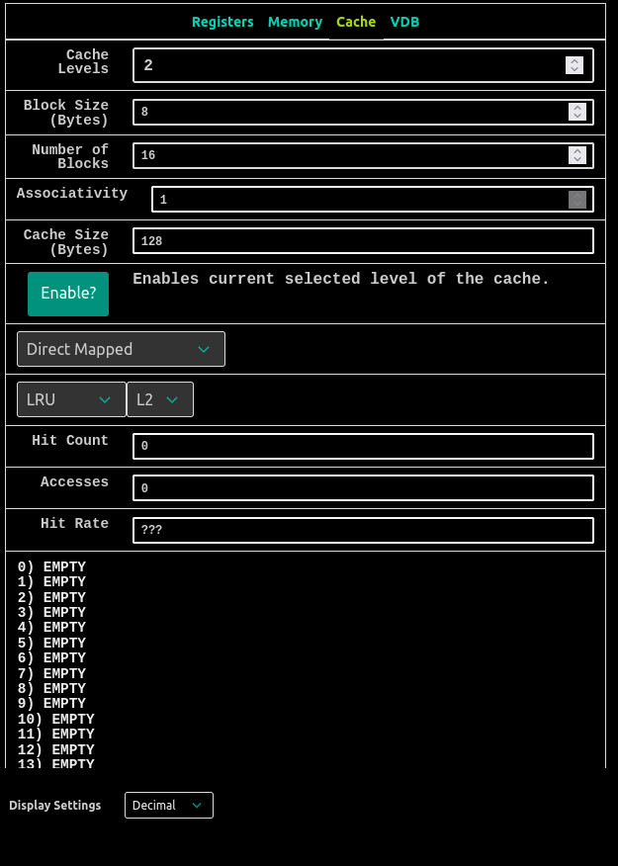
Tasks
1. What is the hit rate of the L1 cache? The L2 cache? Overall? Each hit rate is a decimal rounded to two places.
The hit rate of L1 cache is 0.5 (50%) and L2 cache is 0 (0%).
The overall hit rate is = (( 1 – L1hit rate ) * ( 1 – L2 hit rate ))
= (1- 0.5) *( 1 – 0) = 0.5 = 50%
2. How many accesses do we have to the L1 cache total? How many of them are misses?
The total number of accesses to the L1 cache is 32 out of which 16 were misses and 16 were hit so the hit rate and miss rate for this cache was same 0.5.
3. How many accesses do we have to the L2 cache total? HINT: Think about what the L1 cache has to do in order to make us access the L2 cache.
There were total of 16 accesses we have to the L2 cache, when we had the 16 misses in the L1 cache the same number of misses were in the L2 so there was total of 16 accesses we had to the L2 cache only when we had the misses occur in the L1 cache.
4. What program parameter would allow us to increase the L2 hit rate, but keep the L1 hit rate the same?
When the rep count (a2) was changed from 1 to 2 the hit rate in the L1 and L2 cache was changed to 0.5 ( 50% ). This is because when the miss occur in L1 cache for (rep count 1 ) it looks in L2 cache which was also miss but at the same time L2 fetches the content and store in it and when next time (rep count 2 ) when there is a miss in L1 cache it looks in L2 cache and it was already present there so it had hit that’s why for the 2nd rep count for all the misses in L1 cache we have a hit in L2 cache and overall both L1 and L2 cache has a hit rate of 0.5 ( 50%).
5. Do our L1 and L2 hit rates decrease (-), stay the same (=), or increase (+) as we (1) increase the number of blocks in L1, or (2) increase the L1 block size?

Scenario 1: Increase the number of blocks in L1
When we increase the number of blocks in L1 cache the hit rate for L1 and L2 cache will remain same (=) i.e; the hit rate for L1 would be 50% and for L2 it would be 0% ( only when rep count is 1),but when we increase the rep count to 2 the hit rate of L1 cache would increase to 75%,, but L2 cache will remains same to 0%, So as the rep count goes to the infinity the hit rate of L1 cache would approach to 100%, but L2 will remains to 0%.

Scenario 2: Increase the L1 block size
When we increase the block size of L1 cache the the hit rate of L1 cache would increase(+) , but for the L2 cache it would remains same to 0%.

